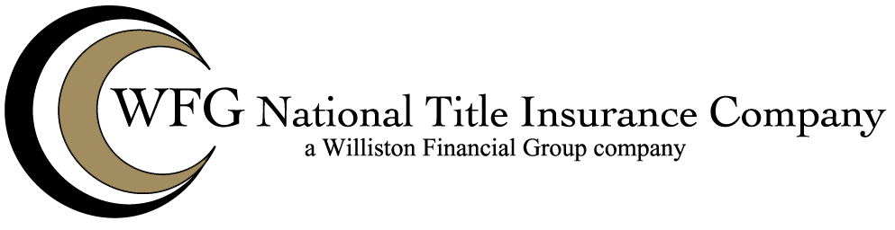

Attached to Policy No. __________
Issued By
WFG NATIONAL TITLE INSURANCE COMPANY

The Company hereby insures against loss or damage by reason of the lack of priority of the lien of the insured mortgage over any lien imposed by law for services, labor or materials, for which the insured has disbursed funds, and which services, labor or material were furnished prior to for an improvement on the land.

This endorsement does not insure against loss or damage by reason of any failure by the insured to comply with or to enforce any of the provision of law known to the insured or any agreement to which the insured is a party which relate to the disbursement of the proceeds of the loan secured by the insured mortgage.

This endorsement is issued as part of the policy. Except as it expressly states, it does not (i) modify any of the terms and provisions of the policy, (ii) modify any prior endorsements (iii) extend the Date of Policy, or (iv) increase the Amount of Insurance. To the extent a provision of the policy or a previous endorsement is inconsistent with an express provision of this endorsement, this endorsement controls. Otherwise, this endorsement is subject to all of terms and provisions of the policy and of prior endorsements.

WFG NATIONAL TITLE INSURANCE COMPANY

By: ______________________________
Authorized Signatory

